**A Project Report on**

**RESUME(PROFILE)**

**USING HTML & CSS**

submitted by

**P. BHAVANA - GQT-S0152**

under the mentorship of

**KESHAV MURTHY**



**GLOBAL QUEST TECHNOLOGIES**

[info@gqtech.in](mailto:info@gqtech.in)

Yelahanka Satellite Town,

Bangalore, Karnataka - 560064.

[2023]

**Signature of the mentor Signature**

**Keshav Murthy G.R.Narendra Reddy**

**INTRODUCTION**

**HISTORY OF HTML:**

**HTML** stands for **Hyper Text Markup Language**.

* It is used to share the information over the internet.
* HTML id developed by Tim Berner’s Lee in 1991.But officially in 1993.
* The First version of HTML consists of “18 tags”
* HTML follows certain rules and regulations setup by “**ISO**”.
* International Organization for standardization is set of rules and regulation are present in ‘**SGML**’ document.

**Versions of HTML**

* **HTML-1** version in the year 1993.
* **Html-2** version in the year 1995.
* **HTML-3.02** version in the year 1997.
* **HTML-4.1** version in the year 1999.
* **HTML-5** version in the year 2014.

**Features of HTML**

* It is easy to Learn.
* It is a tag based language.
* HTML is supported by multiple browsers.
* First web browser is Netscape navigation which was developed by the “Mosiac”.
* It is a portable language.
* **WORA** stands for ‘write once run anywhere’

**Limitation of HTML**

* HTML has less designing capabilities.
* It is dependent on other technology such as CSS in order to develop well designed Webpages.
* HTML has no programming capabilities.
* Using HTML and CSS we can develop only static Web page.
* In order to write the HTML code required an editor such as VS Code, Notepad, Eclipse.
* In order to execute the HTML code we required Web browsers.Like Chrome, Firefox, edge, Opera Safari .

**CSS**

* **CSS** stands for **Cascading Style Sheets**.
* It was developed by W3C to add stylings to the HTML elements.
* W3C stands for World Wide Web.com

**Versions of CSS:**

* CSS-1 (level-1) in the year 1996.
* CSS-2 (level-2) in the year 1998.
* CSS-3 (level-3) in the year 1999.

**Why do we required CSS ?**

* Since HTML has less designing capabilities we cannot create well designed or most appealing Websites.
* Using HTML we cannot add style, animation and transitions to the Webpage.
* Therefore we require CSS to create well designed Webpages.

**Advantages of CSS**

* It allows to add styles, animation and variouses effects to the Webpage.
* It allows us to develop the Webpage rapidly. It is also know as RAD ( rapid application Developer).
* It allows us to separate from formatting develop page to the presentation of Webpage.
* It allows to create well designed Websites.

**Limitations of CSS**

* Using CSS we can perform static styles for the Webpages.
* In order to create dynamic styling for the Websites. We must make use of scripting language such as JavaScript and Libraries of JavaScript.

**Types of CSS:**

1. Inline CSS
2. Internal CSS
3. External CSS
4. Default Browser CSS

**Inline CSS:**

Defining all the CSS properties within the style attribute inside the opening of the tag is referred to as Inline CSS.

**Internal CSS:**

Defining all the CSS properties within <style> inside the HTML document is referred to as Internal CSS.

**External CSS:**

Defining all the CSS properties within as external Script or File with an extension CSS is referred to as External CSS.

* In order to link external CSS file within the HTML document we must use of <link>.
* The value for the ‘ref’ attribute should be ‘stylesheet’.

**RESUME(PROFILE)**

**Scope of the document**

I was created Resume using HTML & CSS.The Scope of the document is:

**Personal Information:** It includes my name, contact information, and a professional summary or objective statement.

**Education:**I have Listed my educational background, including institutions attended, degrees earned, and relevant dates.

**Skills:** I have mentioned technical and soft skills in a clear and organized manner.

**Projects:** I have done two projects in my college, that is also mentioned in this resume.

**Achievements and Awards:** I have completed some courses in online platform i.e Hackerrank.

**Certifications:** I achieved few cirtificates during my college and internships thoes are mentioned in this resume.

**Design and Styling:** Implemented my resume using HTML and CSS skills to design a visually appealing and well-structured resume.

**Technologies Used**

* HTML5
* CSS3

**Our Project**

**Root Structure:**

**RESUME**

→**CODES**

→**HTML_Files**

→Profile.html

→**CSS_Files**

→Profile.css

**PROJECT REPORT**

→FRONT END PROJECT 1 RESUME.DOC

**SCREENSHOTS**

→ALL THE CORRESPONDING SCREENSHOTS OF PAGES.

**Source Code:-**

**Resume.html:**

<!DOCTYPE html>

<!DOCTYPE html>

<html lang="en">

<head>

    <meta charset="UTF-8">

    <meta name="viewport" content="width=device-width, initial-scale=1.0">

    <title>Document</title>

    <link rel="stylesheet" href="Profile.css">

<body>

    <div style="width: 75%;height: 1700px;border: 2px solid gray;margin-left: 15%;">

        <div style="width: 32%;height: 1700px;border-right: 2px solid gray;background-color: rgb(37, 37, 63);">

            <br>

            <img style="border-radius: 50%; width: 150px;height: 150px;margin-left: 60px;" src="photo.JPG">

            <br>

            <br>

            <h5 style="color: white;margin-left: 20px;font-size: 20px;font-family: sans-serif;">Contact</h5>

            <hr style="width: 90%;margin-right: 5px;margin-top: -30px;">

            <br>

            <br>

            <ol?>

                <li id="id2">

                    <p style="color: white;margin-top: -20px;margin-left: 25px;">perlabhavana123@gmail.com</p>

                </li><br>

                <li id="id3">

                    <p style="color: white;margin-top: -20px;margin-left: 25px;">+91 9347931393</p>

                </li><br>

                <li id="id4">

                    <p style="color: white;margin-top: -20px;margin-left: 25px;">1/14-V.Kothapalli,Vemula,Kadapa-516349

                    </p>

                </li><br>

                </ol>

                <h1 style="color: white;font-size: 14px;font-family: sans-serif;margin-left: 20px;margin-top: -15px;">

                    <p>Linkedin:</p><a style="font-family:sans-serif;color: white;font-size: 13px ;"

                        href="www.linkedin.com/in/bhavana-perla-4370a1237">www.linkedin.com/in/bhavana-perla-4370a1237</a>

                </h1>

                <br>

                <br>

                <br>

                <h5

                    style="color: white;margin-left: 20px;line-height:5px;font-stretch: 5px;margin-top: -5px;font-size: 20px;font-family: sans-serif;">

                    Skills</h5>

                <hr style="width: 92%;margin-right: 5px;margin-top: -10px;">

                <br>

                <br>

                <ul

                    style="list-style-type: disc;color: white;list-style-position: inside;margin-top: -20px;line-height: 30px;font-size: 14 px;font-family: sans-serif;">

                    <li>C Programming</li>

                    <li> Core Java / Advanced Java</li>

                    <li>HTML / CSS</li>

                    <li>Java Script</li>

                    <li>Bootstrap</li>

                    <li>SQL / MYSQL</li>

                    <li>Manual Testing</li>

                    <li>Automation Testing</li>

                </ul>

                <br>

                <br>

                <br>

                <h5

                    style="color: white;margin-left: 20px;line-height:5px;font-stretch: 5px;margin-top: -20px;font-size: 20px;font-family: sans-serif;">

                    Achivements</h5>

                <hr style="width: 92%;margin-right: 5px;margin-top: -10px;">

                <br>

                <br>

                <ul

                    style="list-style-type: disc;color: white;list-style-position: inside;margin-top: -20px;line-height: 30px;font-size: 16px;font-family: sans-serif;">

                    <li>Won medal in throwball</li>

                    <li>Java HackerRank⭐⭐⭐⭐⭐</li>

                    <li>SQL HackerRank⭐⭐⭐</li>

                </ul>

                <br>

                <br>

                <br>

                <h5

                    style="color: white;margin-left: 20px;line-height:5px;font-stretch: 5px;margin-top: -20px;font-size: 20px;font-family: sans-serif;">

                    Strengths</h5>

                <hr style="width: 92%;margin-right: 5px;margin-top: -10px;">

                <br>

                <br>

                <ul

                    style="list-style-type: disc;color: white;list-style-position: inside;margin-top: -20px;line-height: 30px;font-size: 16px;font-family: sans-serif;">

                    <li>Quick Learner</li>

                    <li>Good at Time-Management</li>

                    <li>Hardworking</li>

                    <li>Positive Attitude</li>

                </ul>

                <br>

                <br>

                <br>

                <h5

                    style="color: white;margin-left: 20px;line-height:5px;font-stretch: 5px;margin-top: -30px;font-size: 20px;font-family: sans-serif;">

                    Languages</h5>

                <hr style="width: 92%;margin-right: 5px;margin-top: -10px;">

                <br>

                <br>

                <ul

                    style="list-style-type: disc;color: white;list-style-position: inside;margin-top: -20px;line-height: 30px;font-size: 16px;font-family: sans-serif;">

                    <li>English</li>

                    <li>Telugu</li>

                </ul>

                <br>

                <br>

                <br>

                <h5

                    style="color: white;margin-left: 20px;line-height:5px;font-stretch: 5px;margin-top: -25px;font-size: 20px;font-family: sans-serif;">

                    Hobbies</h5>

                <hr style="width: 92%;margin-right: 5px;margin-top: -10px;">

                <br>

                <br>

                <ul

                    style="list-style-type: disc;color: white;list-style-position: inside;margin-top: -30px;line-height: 30px;font-size: 16px;font-family: sans-serif;">

                    <li>Listening Music</li>

                    <li>Playing Games</li>

                </ul>

        </div>

        <h1 style="margin-left: 33%;margin-top: -1650px; font-size: 50px;font-family: sans-serif;">Bhavana Perla</h1>

        <h1 style="font-family: sans-serif;font-size: 16px;margin-left: 35%;margin-top: -10px;">Full Stack Developer</h1>

        <br>

        <br>

        <h2 style="margin-left: 33%;font-size: 20px;font-family: sans-serif;margin-top: 40px;">CAREER OBJECTIVE</h2>

        <hr style="margin-left: 33%;margin-top: -4px;size: 2px;">

        <ul

            style="list-style-type: disc;list-style-position: inside;margin-left: 30%;font-size: 16px;line-height: 30px;">

            <li class="p">Looking for

                responsible and challenging career growth,where I can establish my skills and &nbsp;adeqately that helps in

                increasing the assets of the organization</li>

            <li class="p">I am excited to

                learn new things and seeking for an opportunity in a platform where i can improve&nbsp;pl; myself and develop

                software applications</li>

        </ul>

        <br>

        <h2 style="margin-left: 33%;font-size: 20px;font-family: sans-serif;margin-top: -10px;">PROJECTS</h2>

        <hr style="margin-left: 33%;margin-top: -4px;size: 2px;">

        <ul style="margin-left: 33%;line-height: 30px;font-size: 20px;">

            <li class="ch2"><b>Voting System in organization</b>

                <p style="padding: 10px;">The main Objective of this project is to make the business proposals

                    successful by getting the opinion for the employees</p>

            </li>

            <li class="ch2"><b>Biowaste Management System</b>

                <p style="padding: 10px;">The main objective of to encourage and bring awareness in people to

                    takeinitiative and keep their surroundings clean</p>

            </li>

            <li class="ch2"><b>Daibities Detection Using Machine learning</b>

                <p style="padding: 10px;"> To detect the whether a patient have Diabetes or not to know this.</p>

            </li>

        </ul>

        <br>

        <h2 style="margin-left: 33%; font-size: 20px;font-family: sans-serif;margin-top: -10px;">INTERNSHIPS</h2>

        <hr style="margin-left: 33%;margin-top: -4px;size: 2px;">

        <ul style="margin-left: 33%;line-height: 30px;font-size: 16px;">

            <li style="list-style-type: disc;color:rgb(65, 63, 63);font-size: 16px;"><b>Salesforce Virtual

                    Internship</b></li>

            <p class="p">June 2022-sep 2022</p>

            <h4 class="p">Smartinternz</h4>

            <p class="p">It is Internship of 8 Weeks java Programming is used Learned about basic salesforce concepts

            </p>

        </ul>

        <br>

        <h2 style="margin-left: 33%; font-size: 20px;font-family: sans-serif;margin-top: -10px;">CERTIFICATIONS</h2>

        <hr style="margin-left: 33%;margin-top: -4px;size: 2px;">

        <ul style="list-style-type: disc;margin-left: 33%;font-size: 16px;line-height: 30px;">

            <li class="ch10">CISCO Certificate</li>

            <li class="ch10">Cyber security Certificate</li>

            <li class="ch10">NPTEL Online Certificate</li>

            <li class="ch10">Published a project in national conference[NCKITS-2022]and got certified</li>

        </ul>

        <br>

        <h2 style="margin-left: 33%;font-size: 20px;font-family: sans-serif;margin-top: -10px;">EDUCATION</h2>

        <hr style="margin-left: 33%;margin-top: -4px;size: 2px;">

        <ol id="s">

         <li>2023 -Bachelor of Technology in CSE

            <br>&nbsp;&nbsp;&nbsp;&nbsp;&nbsp;&nbsp;&nbsp;&nbsp;&nbsp;&nbsp;&nbsp;&nbsp;

            Sree Vidyanikethan Engineering College-Tirupati

            <br>&nbsp;&nbsp;&nbsp;&nbsp;&nbsp;&nbsp;&nbsp;&nbsp;&nbsp;&nbsp;&nbsp;&nbsp;

            CGPA-8.86

        </li>

        <li>2020 -Diploma in CSE

            <br>&nbsp;&nbsp;&nbsp;&nbsp;&nbsp;&nbsp;&nbsp;&nbsp;&nbsp;&nbsp;&nbsp;&nbsp;

            Loyola Polytechnic College

            <br>&nbsp;&nbsp;&nbsp;&nbsp;&nbsp;&nbsp;&nbsp;&nbsp;&nbsp;&nbsp;&nbsp;&nbsp;

            Percemntage-89.38

        </li>

        </ol>

     </div>

    <div id="id7"></div>

</body>

</html>

**Profile.css:**

img{

    height: 180px;

    width: 100%;

    border: 2px solid rgb(221, 234, 241);

    margin-left: -4px;

    border-radius: 50%;

    margin-top: -3px;

}

#id2{

    list-style-image: url(email1.jpg);

    margin-left: 30px;

    margin-top: -15px;

font-size: 16px;

}

    #id3{

        list-style-image: url(phone1.jpg);

        margin-left: 30px;

        margin-top: -15px;

        font-size: 16px;

    }

    #id4{

        list-style-image: url(email1.jpg) ;

        margin-left: 30px;

        margin-top: -15px;

        font-size: 16px;

    }

   .id5{

    margin-right: -10%;

   }

   .ch{

    font-size: 20px;

    color: rgb(78, 76, 76);

   }

   .ch2{

    font-size: 16px;

    color:rgb(78, 76, 76);

   }

   .ch10{

    color:rgb(65, 63, 63);

    line-height: 40px;

    font-size: 16px;

    font-family: sans-serif;

   }

   #id7{

    width: 50.9%;

    height: 180px;

   margin-top: -1702px;

   margin-left: 39.3%;

   background-color:rgb(219, 156, 41);

   }

   #id8{

    list-style-position: outside;

   }

   .h{

    margin-top: 40px;

    font-size: 20px;

    font-family: sans-serif;

    margin-left: 34%;

   }

#s{

    margin-left: 33%;

    font-size: 16px;

    font-family: sans-serif;

    color: rgb(65, 63, 63);

    line-height: 30px;

    margin-top: 20px;

    list-style-type: disc;

}

#p{

    font-size: 16px;

    font-family: sans-serif;

    text-align: justify;

}

**Output:**

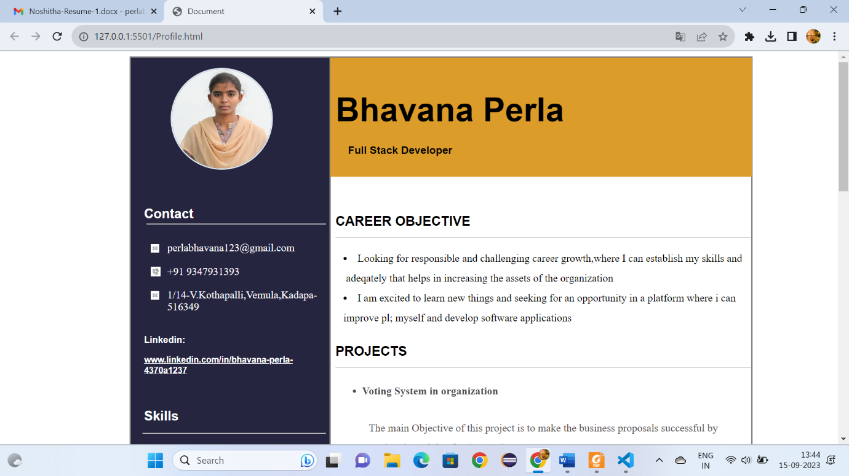

Fig:1.1

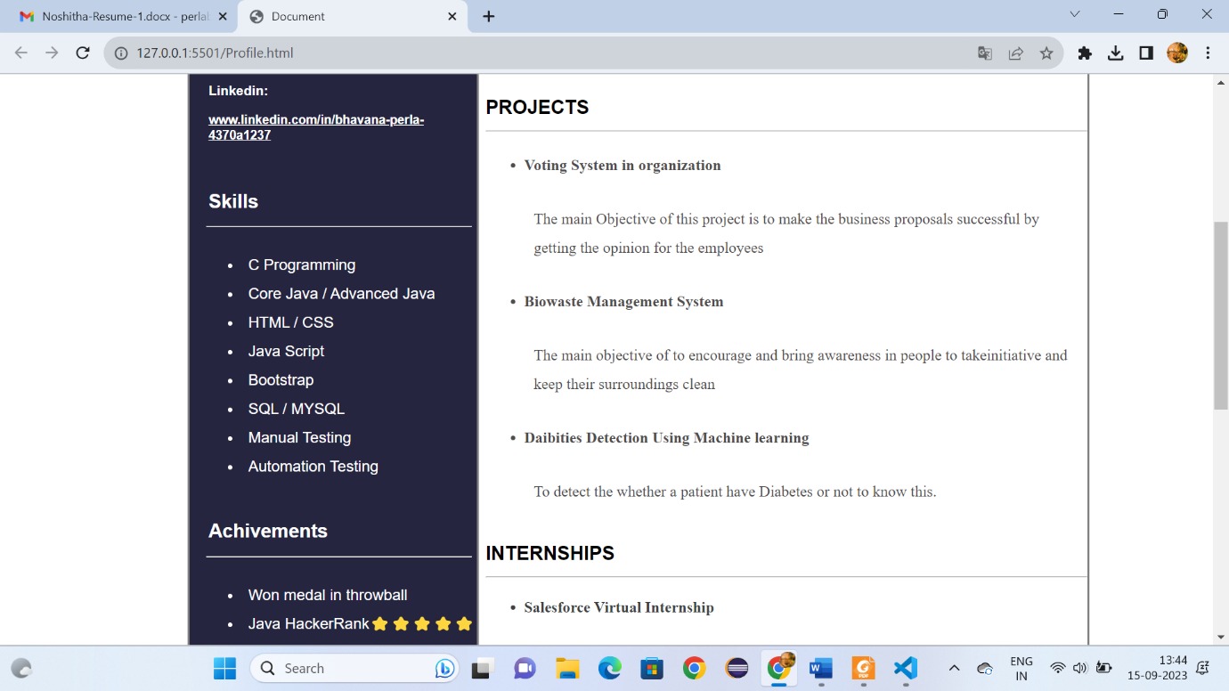

Fig:1.2

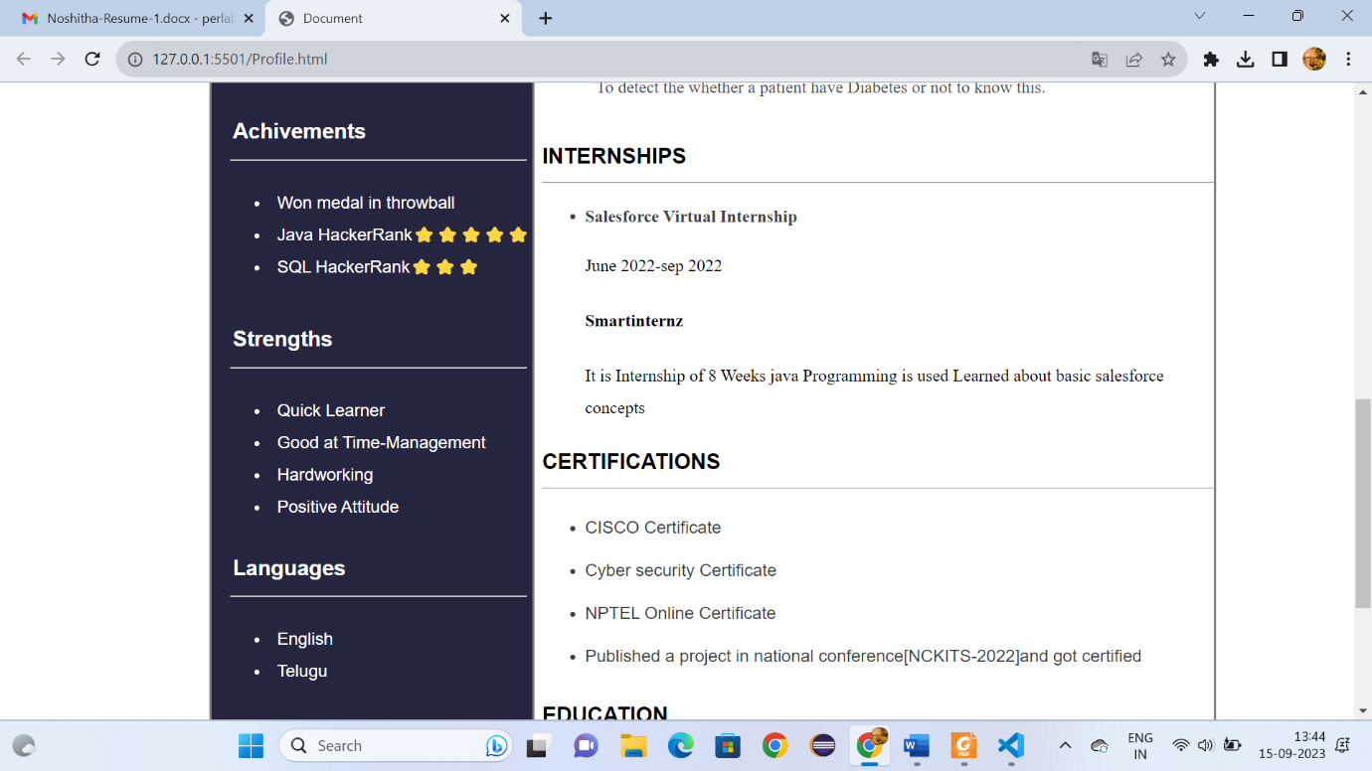

Fig:1.3

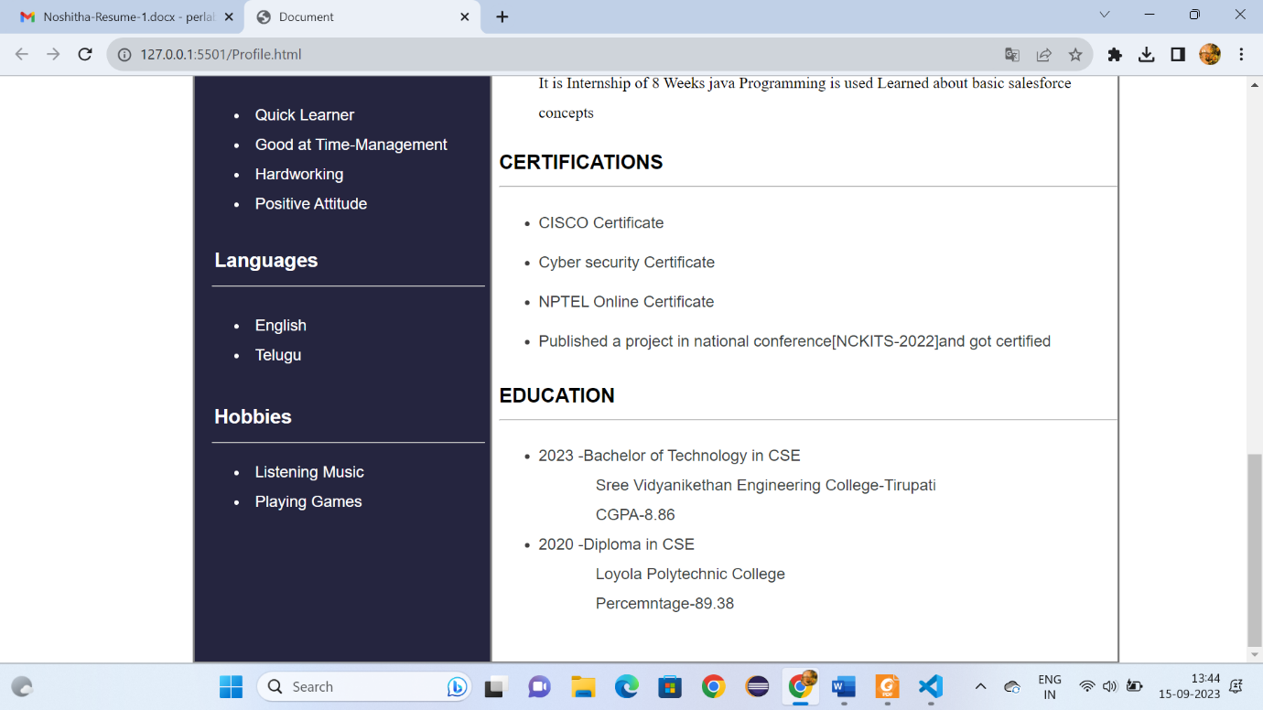

Fig:1.4

**Conclusion**

"In crafting this resume using HTML and CSS, I aimed to create a professional and visually engaging representation of my qualifications and experiences. With a strong educational background, a proven track record in [Computer science and Engineering], and a diverse skill set that includes [Java fullstack Development, HTML,CSS,Java Script,MySql].

This resume serves as a snapshot of my journey and abilities, and I am ready to provide more detailed information and discuss how I can add value to your organization.